Kiewiet Cottage

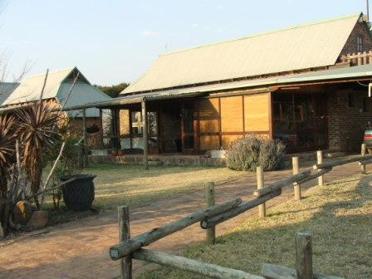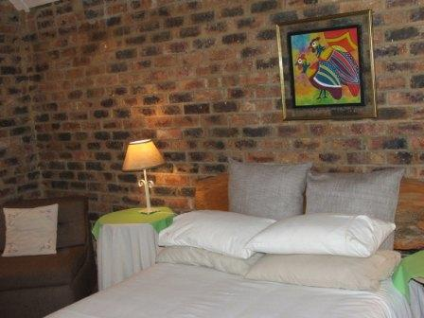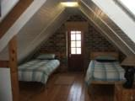

Kiewiet Cottage is situated at Stilbaai Yacht Club on the Vaal Dam. For those wanting a quiet weekend away, Kiewiet offers tranquil and scenic surroundings only an hour’s drive from Johannesburg.
Available recreational activities
For those needing some physical activity (or to keep your friends and family busy while you are flying) ....................
- Bring your walking/running shoes and explore the surrounding hills on the neighbouring farm.
- Plenty opportunity for water sport: bring a canoe, kiteboard, windsurfer or paddle ski.
- Sailing: sailors can bring their own boat, or charter a catamaran. Sailing tuition can be pre-arranged. (SA Dart catamaran champion). Prices on request.
- Sailing on a trimaran/sundowner cruises can be pre-arranged: R100 pp per hour/part there of, minimum two persons, maximum six.
- Your mountain bikes will be put to good use.
- Prolific birdlife – bring your binoculars and camera.
- Paragliders: winch launches offered to licensed pilots, weather permitting.
- Swimming: (swimming pool at clubhouse).
- Volleyball court.

- Stilbaai Yacht Clubhouse offers:
  - Cool drinks, crisps, sweets, ice creams and alcoholic beverages for sale at the club house bar.
  - DSTV
  - Pool table
Please use the ablutions at the Yacht Clubhouse, not the bush!
Accommodation
Kiewiet cottage offers the following:
- Self catering unit but meals can be provided if pre-requested.
- Sleeping facilities for two to six people: One double bedroom, two single beds in loft and sleeper couch on verandah.
- One bathroom with shower, basin and toilet.
- Fully equipped kitchen, gas stove.
- Enclosed verandah.
- Braai facilities. Charcoal can be purchased here. Please bring firelighters.
- Wood burning stove in lounge.
- Table tennis and dart board.
- Electricity, with some electrical appliances. No microwave, no television.
- Under cover parking.
- Bedding and towels supplied. Please bring your own swimming towels.
- Security: Yacht club has electric fencing, a guarded gatehouse and restricted access.
Rates:
R390 per nightfor two people. Additional R95 per night per extra adult, or R75 per child (2-12 years). Minimum stay two nights.
Regret:
- NO pets allowed.
- No fishing on the Stilbaai premises.
- No day visitors, unless pre-arranged. R50 pp per day.
- No quad bikes.
- Strictly NO SMOKING in Kiewiet cottage please.
- No jet ski’s
Thank you!
Laetitia and Ben Mienie.
083 538 6357
lmienie@gmail.com

